 | 10.1.9 Editors - Compositor Editor - Header - Add Menu - Filter
Table of content
Detailed table of content 1
Add menu - Filter - Blur 3
Bilateral Blur 3
Blur 4
Bokeh Blur 5
Defocus 6
Directional Blur 7
Vector Blur 8

Detailed table of content

Detailed table of content
Detailed table of content 1
Add menu - Filter - Blur 3
Bilateral Blur 3
Inputs 3
Image 3
Determinator 3
Size 3
Threshold 3
Outputs 3
Image 3
Blur 4
Inputs 4
Image 4
Size 4
Type 4
Flat 4
Tent 4
Quadratic 4
Cubic 4
Gaussian 4
Fast Gaussian 4
Catmull-Rom 4
Mitch 4
Extend Bounds 4
Separable 5
Outputs 5
Image 5
Bokeh Blur 5
Inputs 5
Image 5
Bokeh 5
Size 5
Mask 5
Extend Bounds 5
Outputs 5
Image 5
Defocus 6
Inputs 6
Image 6
Z 6
Properties 6
Bokeh Type 6
Angle 6
F-Stop 6
Max Blur 6
Scene 6
Use Z-buffer 7
Z Scale 7
Image 7
Z 7
Outputs 7
Image 7
Directional Blur 7
Inputs 7
Image 7
Samples 7
Center X, Y 7
Distance 7
Rotation 7
Scale 8
Translation subtab 8
Amount 8
Direction 8
Outputs 8
Image 8
Vector Blur 8
Inputs 8
Image 8
Speed 8
Z 8
Samples 8
Shutter 8
Outputs 8
Image 8

Add menu - Filter - Blur

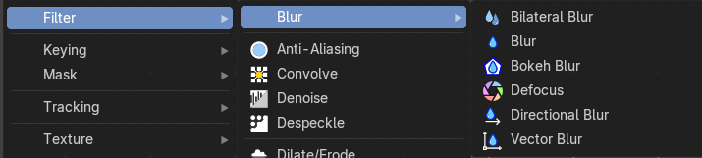
The Filter add menu contains multiple filters you can use on image data, including blurs and other lens effects.

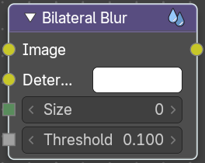
Bilateral Blur
The Bilateral Blur node performs a high-quality adaptive blur on the source image, allowing to blur images while retaining their sharp edges.
It can be used for various purposes like: smoothing noisy render passes to avoid longer computation times in example ray-traced ambient occlusion, blurry refraction's/reflections, soft shadows, or to make non-photo realistic compositing effects.

Inputs

Image
Standard image input. If only the image input is connected, the node blurs the image depending on the edges present in the source image.

Determinator
Which is non-obligatory and if the Determinator is connected, it serves as the source for defining edges/borders for the blur in the image. This has great advantage in case the source image is too noisy, but normals in combination with Z-buffer can still define exact borders/edges of objects.

Size
The size of the blur in pixels.

Threshold
The threshold of the blur area. Pixels are considered to be in the blur area if the average difference between their determinator of the center pixels is less than this threshold.

Outputs

Image
Standard image output.

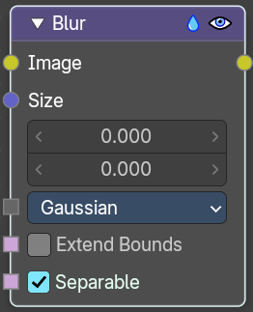
Blur
The Blur node provides several blur modes to blur an image. The icon top right allows you to collapse and show the image part of the node.

Inputs

Image
Standard image input.

Size
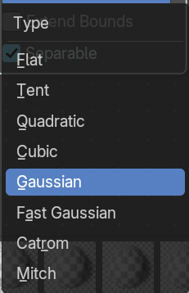
The optional Size input will be multiplied with the X and Y blur radius values. It accepts also a value image, to control the blur radius with a mask. The values should be mapped between (0 to 1) for an optimal effect.

Type
The different blur types.

Flat
Simply blurs everything uniformly.

Tent
Preserves the high and the lows better by making a linear falloff.

Quadratic
Looks similar to Gaussian but can be a little faster but slightly worse looking.

Cubic
Preserve the highs, but give an almost out-of-focus blur while smoothing sharp edges.

Gaussian
Gives the best looking results but tends to be the slowest.

Fast Gaussian
An approximation of the Gaussian.

Catmull-Rom
Catmull-Rom keeps sharp contrast edges crisp.

Mitch
Preserve the highs, but give an almost out-of-focus blur while smoothing sharp edges.

Extend Bounds
Allows the image, that is being blurred, to extend past its original dimension.

Separable
Blur along the horizontal and vertical directions independently. This method is faster.

Outputs

Image
Standard image output.

Bokeh Blur
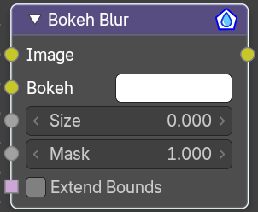
The Bokeh Blur node generates a bokeh type blur similar to Defocus. Unlike defocus an in-focus region is defined in the Compositor.
Several performance optimizations are also available such as OpenCL support, calculation area restriction and masking.

Inputs

Image
Standard image input.

Bokeh
This is an input for the Bokeh Image node.

Size
Size controls the amount of blur. Size can either be a single value across the entire image or a variable value controlled by an input image. In order to use the latter, the Variable Size option must be selected. See the examples section below for more on how to use this.

Mask
Here you can input a Box Mask matte node or a Mask input node to restrict the area of the image the blur is applied to. This could be helpful, for example, when developing a node system by allowing only a small area of the image to be filtered thus saving composite time each time adjustments are made.

Extend Bounds
Extend the bounds of the input image to fully fit the blurred image.

Outputs

Image
Image output.

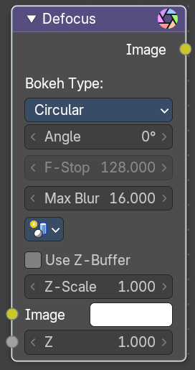
Defocus
It is typically used to emulate depth of field (DOF) using a post-processing method with a Z-buffer input. But also allows to blur images that are not based on Z depth too.

Inputs

Image
Standard image input.

Z
Z-buffer input, but could also be a (greyscale) image used as a mask, or a single value input.

Properties

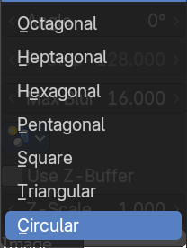
Bokeh Type
The number of iris blades of the virtual camera’s diaphragm.
Disk (to emulate a perfect circle) or Triangle (3 blades), Square (4 blades), Pentagon (5 blades), Hexagon (6 blades), Heptagon (7 blades) or Octagon (8 blades).

Angle
This button is deactivated, if the Bokeh Type is set to Disk. It can be used to add a rotation offset to the Bokeh shape. The value is the angle in degrees.

F-Stop
This option controls the amount of focal blur in the same way as a real camera. It simulates the aperture f of a real lens’ iris, without modifying the luminosity of the picture. The default value 128 is assumed to be infinity: everything is in perfect focus. Half the value will double the amount of blur. This button is deactivated, if No Z-buffer is enabled.

Max Blur
This value limits the amount of blur by setting a maximum blur radius. Could be used to optimize the performance. The default value of 0 means no limit.

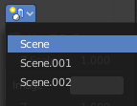
Scene
Select the linked scene. Scenes can be created in the properties editor in the Scene properties tab in the Scene panel.


Use Z-buffer
Should be activated for a non Z-buffer in the Z input. No Z-buffer will be enabled automatically whenever a node that is not image based is connected to the Z input.

Z Scale
Only active when No Z-buffer is enabled. When No Z-buffer is used, the input is used directly to control the blur radius (similar to F-Stop when using the Z-buffer). This parameter can be used to scale the range of the Z input.

Image
Input Image

Z
The Z value of the image.

Outputs

Image
Image output.

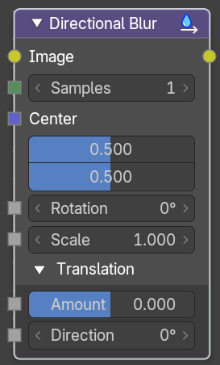
Directional Blur
Blurs an image in a specified direction and magnitude. Can be used to fake motion blur.

Inputs

Image
Standard image input.

Samples
The number of samples to compute the blur.

Center X, Y
Sets the position where the blur center is. This makes a difference if the angle, spin, and/or zoom are used.

Distance
How large the blur effect is.

Rotation
Rotates the image each iteration to create a spin effect, from the center point.

Scale
Scales the image each iteration, creating the effect of a zoom.

Translation subtab

Amount
The translation amount relative to the image.

Direction
The translation direction.

Outputs

Image
Image output.

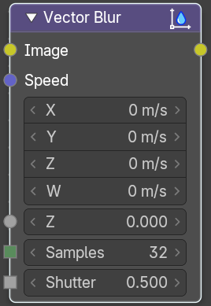
Vector Blur
The Vector Blur node is a fast method for simulating Motion blur in compositing. It uses the vector speed render pass to blur the image pixels in 2D.

Inputs

Image
Image input, to be linked to the “Combined” render pass.

Speed
Input for the “Vector” render pass. See Cycles render passes.

Z
Z depth, to be linked to the “Depth” render pass.

Samples
Quality factor.

Shutter
Time between open and close the shutter.

Outputs

Image
Motion blurred image output.

